Bonus Lab: Rearming the 180 Trial Period for Server 2012 R2

Overview

Microsoft permits the rearming of the 180-day trial period for Server 2012 R2 up to five times. Installing certain roles and features during the trial period seems to cause the trail period to end. In this instance installing the Hyper-V role caused the 180-trail period to end.

Typing the following command in PowerShell will rearm the 180-day trial period.

slmgr.vbs -rearm

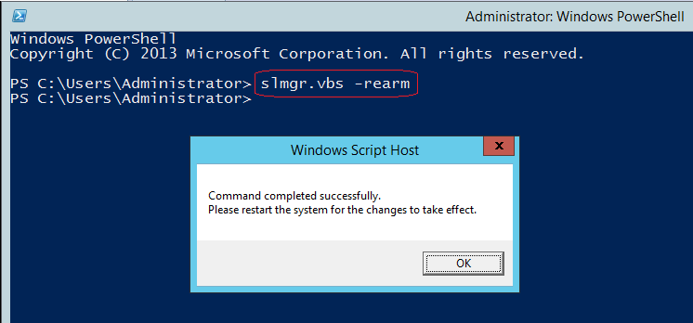

This rearming is only to be used for testing and development and should be used on a server in a production environment.

End of Lab!